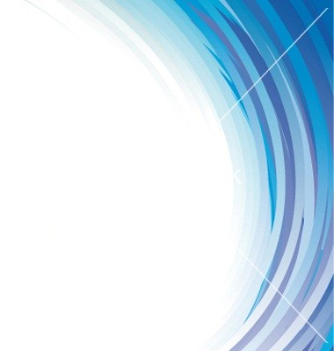

Department of Mechanical Engineering
Faculty of Engineering & Technology
JAMIA MILLIA ISLAMIA

A Brief Report on
SAE JMI
Achievements and Awards

Prof. M.M.Hasan Prof.Abid Haleem
Faculty Advisor Head, Mech.Engg.

About SAE

The Society of Automotive Engineers (SAE) is an international engineering society established to develop core competence in the area of aerospace, automotive and commercial vehicles. The members of SAE are industry leaders and workers from all areas of the transportation industry, as well as thousands of college students from around the world.SAE International has more than 1,33,000 members in 100 nations.It reflects the very essence of mobility engineering different people from different countries working together toward a common goal.
SAEINDIA is India's leading resource for mobility technology. As an individual member driven society of mobility practitioners the ownership of SAEINDIA wrests with its members who are Individuals from the mobility community, which includes Engineers Executives from Industry, Government Officials, Academics and Students. Members learn hands-on skills, as well as effective team working strategies that will be essential to succeed in industry upon graduation. Members engage in practical engineering, learn complex manufacturing techniques, and feel the pressure of working under deadlines and strict budgets. Best of all, members receive great satisfaction in seeing their designs make the transition from paper to working machines, which consistently finish near the top at competitions.

The Ladder of Success under SAE INDIA JMI

- SAE BAJA 2011: Team ‘Rage against the Machine’

- QUEST INGENIUM DESIGN CONTEST

- SAE EFFICYCLE 2011: Team ‘THOR’

- SAE EFFICYCLE 2012: Team ‘THOR’

- SAE BAJA 2011: Team ‘Rage against the Machine’

The Mini-Baja competition challenges college students to design, fabricate, and race a miniature Baja style off-road vehicle. Rule guidelines place restrictions on the engine and frame, testing the imagination, knowledge, and creativity of the students. The vehicles are judged through both dynamic and static events. Students design the Mini-Baja car as if it is a prototype for a company, so cost, appearance, reliability and performance all become key factors in judging. This competition, like all SAE competitions bring students together from not only across the country, but from around the world. In the year 2010, a team comprising of 20 Mechanical Engineering Department Students named ‘Rage Against the Machine’ was formed which participated in SAE BAJA competition organized by SAE India. The Team qualified for the final event. They designed, fabricated and tested the BAJA Car. The final event was held in Indore and the team due to an accident could not get the prize. The achievement and innovations of the team gained a lot of media publicity.

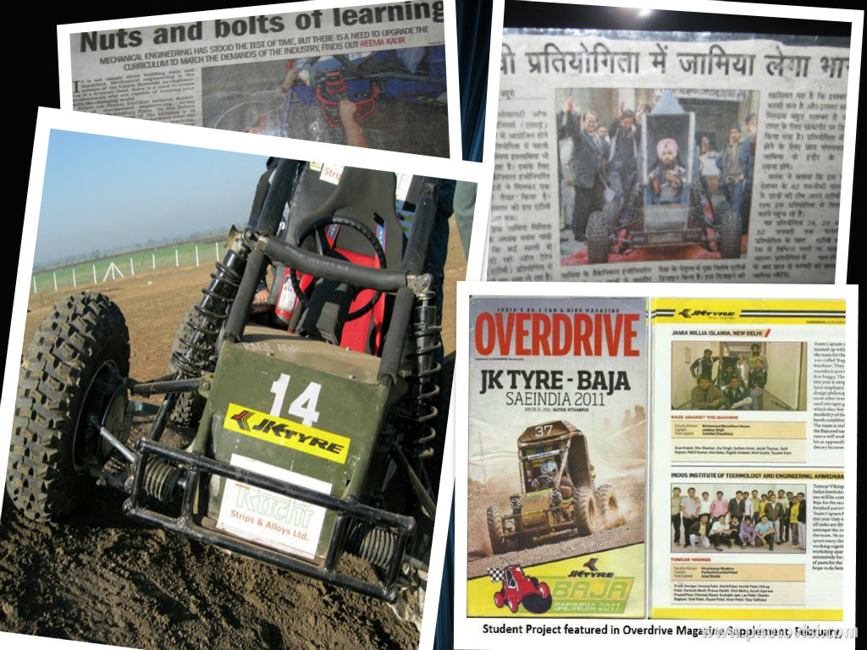

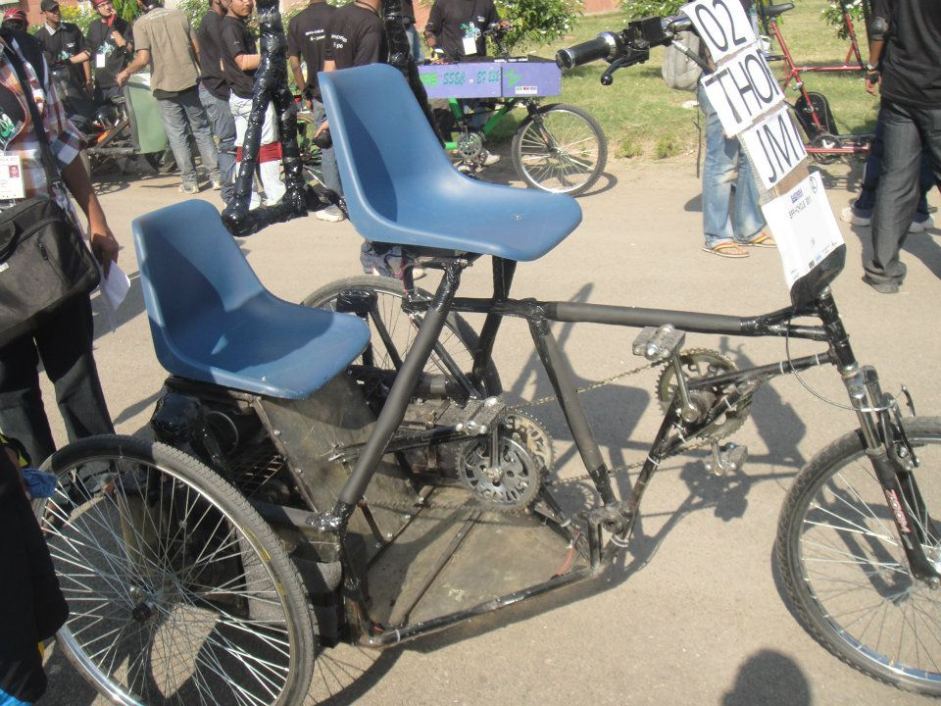
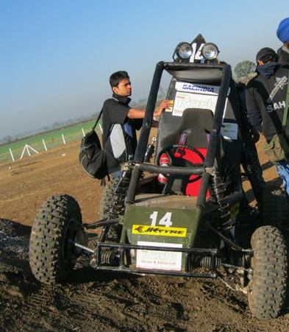
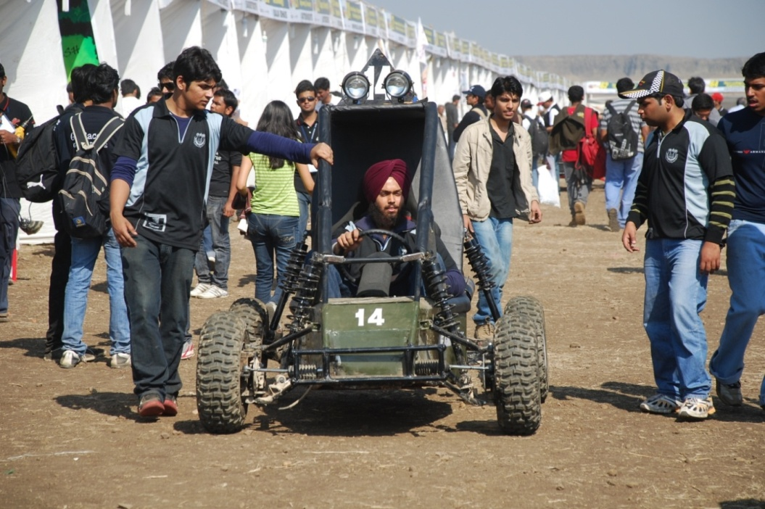
Jaideep Singh Driving the Baja Car during the Event

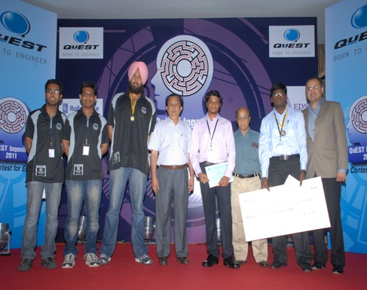

Team Members along with Chief Guest Dr. G Madhavan Nair
(former Chairman of ISRO and Secretary to the Department of Space)

2) QUEST INGENIUM Design Contest
Students of Mechanical Engg. Department, Jamia Millia Islamia formed a Team named Rage against the Machine which was one of the 123 entries from 56 colleges from 39 cities across 13 states to send abstracts and register for the contest in the first phase of the contest.
The intermediate stages included two rounds of telephonic interviews which were a breeze for the team members. After a stringent process of evaluation, Team was selected amongst top ten short listed teams and was invited to Quest premises in Bangalore to present their projects to an independent jury.
Further at the main Event Presentation round in June 2011 the team proved its mettle by impressing the empanelled judges. The team won the third prize and bagged a BRONZE MEDAL along with a cash prize of TWENTY FIVE THOUSAND RUPEES.
The concept and idea drew a lot of attention in the press and media and the students were acknowledged for their efforts and achievements.
- SAE EFFICYCLE 2011: Team ‘THOR’

The SAE JMI Students of Mechanical Engineering Department involved themselves in a new, Green and innovative Project that required designing, validating and fabricating a three wheeled hybrid human powered electric vehicle, which has the capacity to act as a good viable option for local transportation. A Team comprising 8 students under the able guidance of Prof. M.M.Hasan and leadership of Akhil Gupta, a Pre-Final Year student participated in the SAE EFFICYCLE 2011. Out of 90 teams that participated, the team emerged successful to clear the virtual round and appear for the final event.

The vehicle design is made keeping three designs in mind: racing model, agricultural model and commercial model.

Members with the Award

MEMBERS | ROLES | RESPONSABILITY
PROF. M. M. HASAN | FACULTY ADVISOR | GUIDANCE
AKHIL GUPTA | TEAM LEADER | SUSPENSION,BIO FILTER, ERGONOMICS
JAIDEEP SINGH | DESIGN HEAD | CAD MODEL, ANALYSIS
ALAN BABU | DESIGN MEMBER | PART MODELLING
ANKIT GUPTA | BRAKING | BRAKE SELECTION & VALIDATION
RAGHIB RAJA | STEERING & TIRE | TIRE SELECTION, STEERING GEOMETRY
SAHIL ARORA | ELECTRICAL | MOTOR & DYNAMO SELECTION, CIRCUIT
ANKUR WADHWA | MARKETTING | MARKET AVAILABILITY & COST ANALYSIS
PRATEEK BANSAL | ANTHROPROMETRIC | DATA COLLECTION & PLOTTING

The team gave its best and in its maiden attempt achieved a rare feat of bagging the award for “BEST UTILITY & HANDLING”.The unique Steering, the excellent and reliable electric drive and smooth transmission enabled the success of the vehicle.
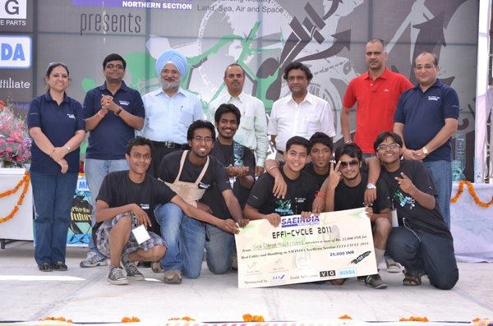

- SAE EFFICYCLE 2012: Team ‘THOR’

JAMIA MILLIA ISLAMIA LAUNCHES ITS OWN HYBRID ELECTRIC VEHICLE
This year once again under the able guidance of Prof. M.M.Hasan and leadership of Prateek Bansal, a Pre- Final year Mechanical Engineering student, the team THOR comprising eight students, from the Department of Mechanical Engineering , participated in SAE Efficycle 2012, a three day national event held at University Institute of Technology, Chandigarh from the 12th – 14th of October, 2012.

MEMBERS | ROLES | RESPONSABILITY
PROF. M. M. HASAN | FACULTY ADVISOR | GUIDANCE
PRATEEK BANSAL | TEAM LEADER | SUSPENSION,BIO FILTER, ERGONOMICS
ANKUR WADHWA | DESIGN HEAD | CAD MODEL, ANALYSIS
ALAN BABU | DESIGN MEMBER | PART MODELLING
AKHIL GUPTA | BRAKING | BRAKE SELECTION & VALIDATION
ANKIT GARG | STEERING & TIRE | TIRE SELECTION, STEERING GEOMETRY
SAGAR GUPTA | ELECTRICAL | MOTOR & DYNAMO SELECTION, CIRCUIT
SHUBHAM GARG | MARKETTING | MARKET AVAILABILITY & COST ANALYSIS
MOHD. AREEB | ANTHROPROMETRIC | DATA COLLECTION & PLOTTING

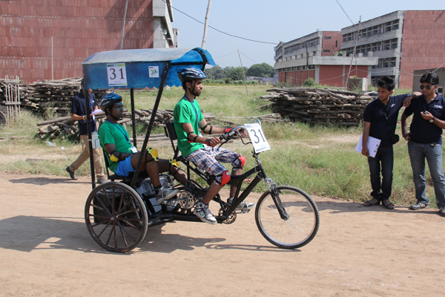
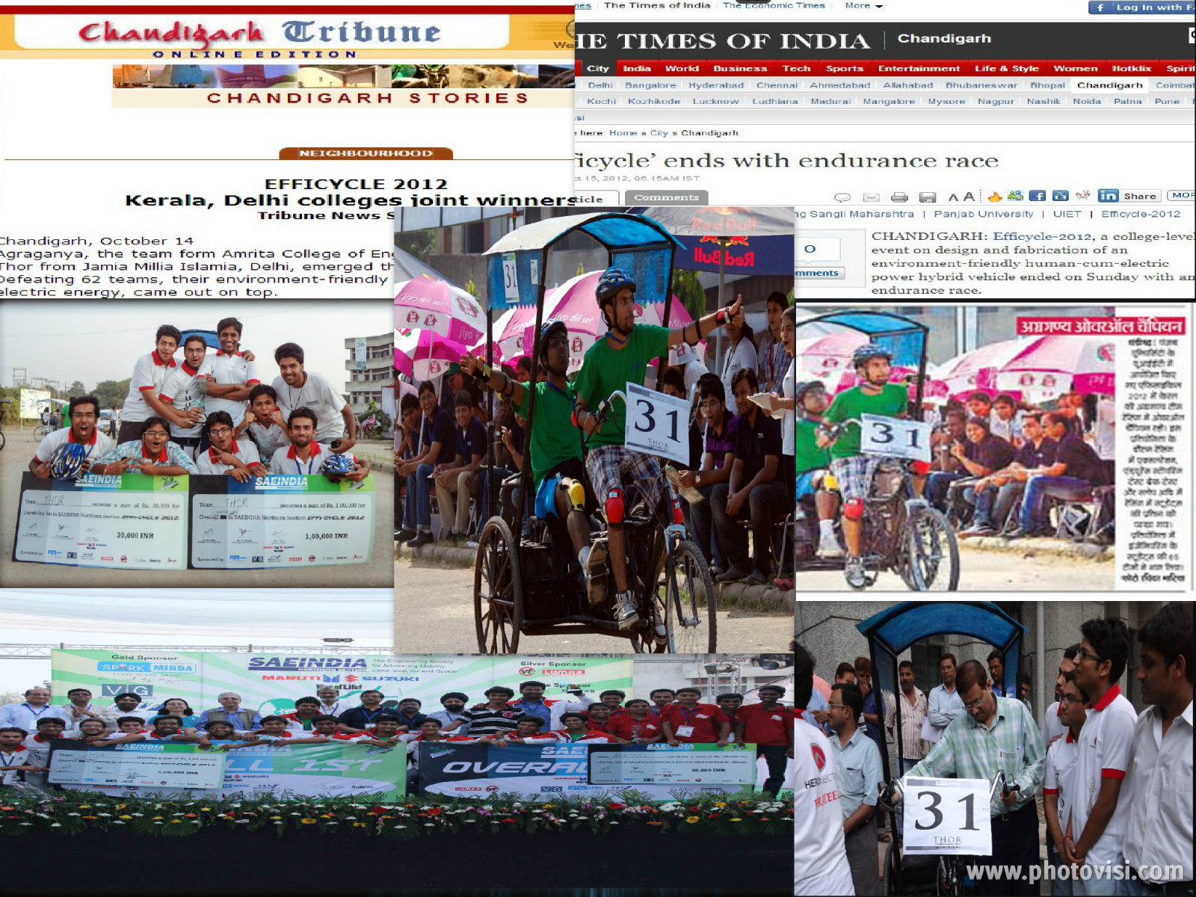
The achievement and innovations of the team gained a lot of media publicity.

SAE Efficycle is a national level Inter-Collegiate competition organized by SAE (Society of Automotive Engineers) INDIA every year at UIET, Chandigarh. A team of 8 budding engineers have to design, validate and fabricate a hybrid three wheeled Electric vehicle (all the three wheels not in straight line). This year over 120 colleges from all over India including IIT’S and NIT’S registered for the event out of which 62 colleges were selected for the final round.
The event consists of two main sub events, the Virtual event and the Final Field event. The Virtual event was held at four different campuses across India where representatives of every team would present a virtual and simulated model of their visualization of the vehicle assisted with calculations and machine design concepts. The Field event was spanned across three days exposing young engineering minds to the nitty-gritty of vehicular design and fabrication. The event culminates with a final durability race in which all eligible teams would take part in a 90 minute race across UIET campus covering a lap stretch of over 1.4 kms.
Last year in the same event, Jamia Millia Islamia in its maiden attempt, secured the award for “Best Utility and Handling” clubbed in with a cash prize of Rs.25000. Carrying the Huge burden of expectations was a tough ask for the relatively fresh team but surprisingly the team exceeded expectations when it achieved the rare double of bagging the awards for “Overall 1st position” and “Winner Durability Race” bagging a total cash prize of Rs. 1.3 Lakhs. The team emerged winners of the race with a total lap count of 28 and went on to secure the overall first prize as well.
The team believes that the motor of their vehicle, the innovatory spring suspension, and the easy driving helped them to win the competition.
The Team received support from the Department of Mechanical Engineering, giving permission to use the I.C.Engines Lab and machines for the fabrication of the vehicle. The team was also supported by Hero Electric limited which provided batteries for the vehicle. The cost of the vehicle is estimated to be Rs 28000 with a mileage on full charging to be very close to around 8 hours.
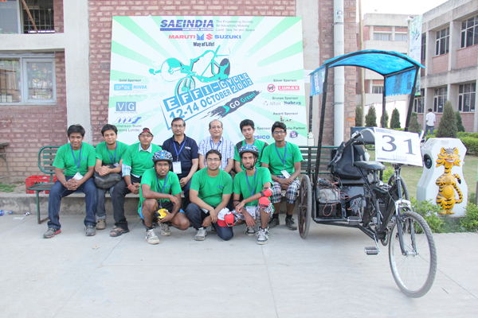
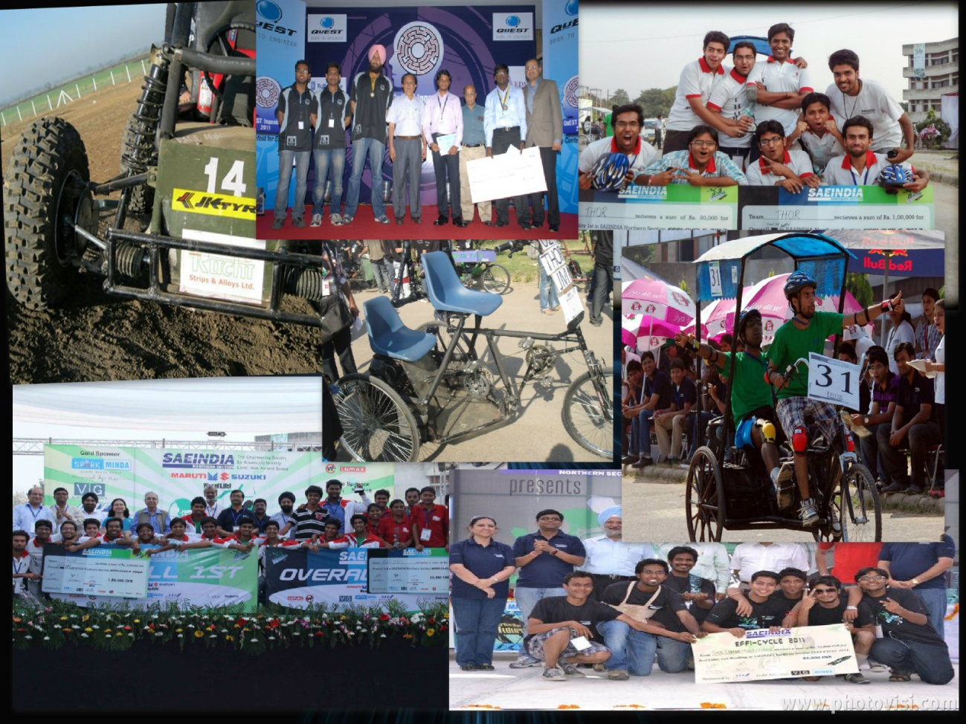

SAE JMI Executive committee Members (2012-2013)

Prof. Abid Haleem Patron
Prof.M.M.Hasan Faculty Advisor
Prof.M.Islam Additional Faculty Advisor

- Mohd. Asad Aman Chairperson
- Tauseef Alam Vice Chairperson
- Alan Babu Vice Chairperson
- Mohd. Raghib Shakeel General Secretary
- S. Fraz Haider Nabi General Secretary
- Ankit Garg General Secretary
- Akhil Gupta Media Coordinator
- Mohd. Bilal Treasurer
- Shubham Garg Treasurer
- Sagar Gupta Joint Secretary
- Mohd. Areeb Joint Secretary
- Mohd. Ashraf Akhtar Joint Secretary
- Dipul Chawla Joint Secretary
- Reshma Yasmeen Joint Secretary
- Narad Verma Joint Secretary
- Somi Doja Event Coordinator

